**Important Note**: pls take backup of configuration files when you going to change anything in configuration files.

Command: cp <source-file> <dest_file/location> ----- this will copy file to new name /location

mv <source-file> <dest_file> ----- it will rename file name.

--------------------------------------

**Server setup for Ansible environment procedure:**

**Create 2 AWS Cloud servers in public-faced subnet which connect to internet and with proper security group and name them as your wish.**

**In this session we will use one server as a Ansible controller server and another is a ansible_demo as a normal web/app server**

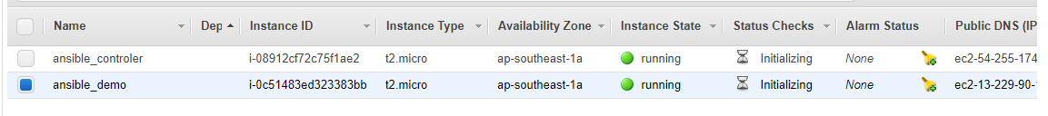

**1.Ansible_controler server setup:**

Login into ansible_controler(names are your wish) server and set the name as per below screen shot and reboot

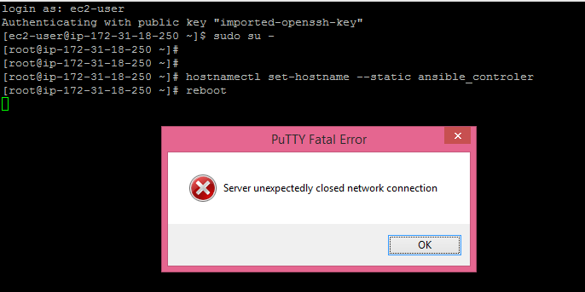

Again re-login into ansible_controler server as shown below.

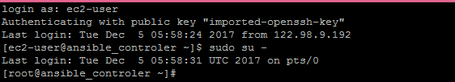

Setup local DNS for your ansible environment.

Open /etc/hosts as per below screen shot and make entry of your ansible_controler server and ansible_demo server **Private IP’s** as per below screen shot. Save and exit with command **:wq!**

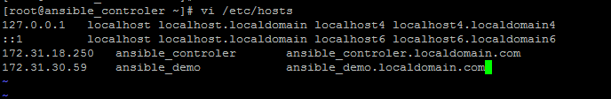

Reboot once again.

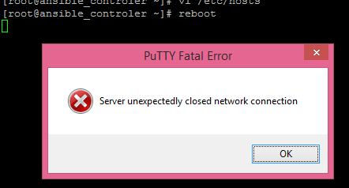

And re-login

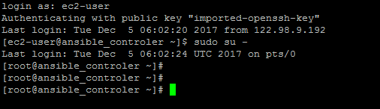

Create a user as per below screen shot ( user name is your wish)

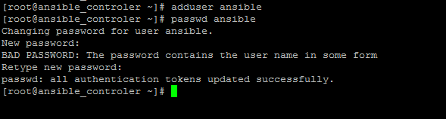

Give sudo access to him. ------🡪 pls be careful while changing sudoers file.

Open /etc/sudoers file. You can see **root** entry. Below root entry add user name as per below screenshot.



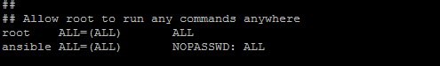

Open /etc/ssh/sshd_config file as per below screen shot



You can find below entries

**PermitRootLogin yes** -- uncomment this

**PasswordAuthentication yes** -- uncomment this

**#PasswordAuthentication no** -- **comment this**

**AllowAgentForwarding yes** -- uncomment this

**AllowTcpForwarding yes** -- uncomment this

**UseLogin no** -- uncomment this

And restart the sshd services as shown below.



Copy from your local laptop and paste your **.pem** key to server as shown below.

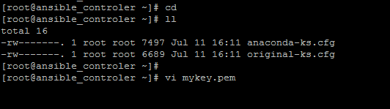

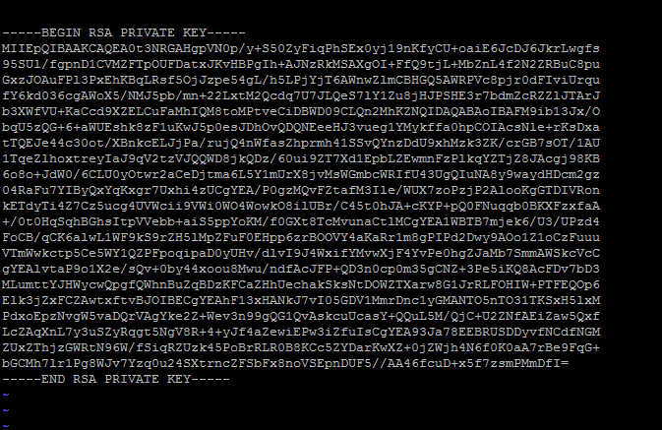

Change permissions as per below



Try to connect to your ansible_demo server as shown below from **.pem** file location

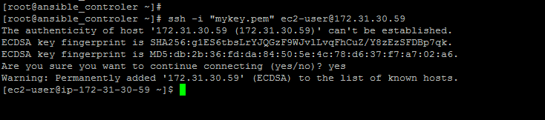

Login with user which you have created, in this case I have created **ansible**.

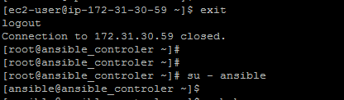

Create ssh keys to login to ansible_demo server for password less login

Command: ssh-keygen and press enter ,enter ,enter

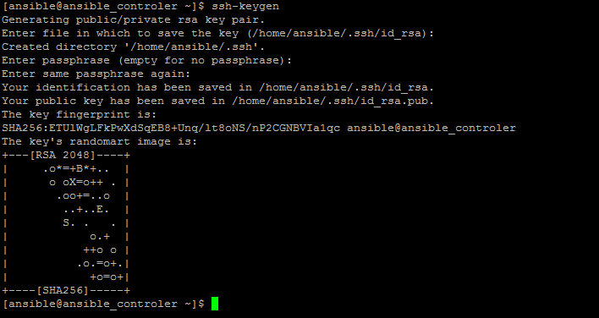

Now you can see .pub keys in your ansible_controler server

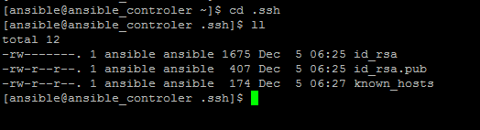

**2.Ansible_demo server setup:**

Pls follow same steps which you have performed to configure ansible_controler server.

**3. Initiate communication between 2 servers**:

Type below command as per below screen shot in your **ansible_controler server** from .ssh directory

Type cd .ssh , press enter and follow screenshot.

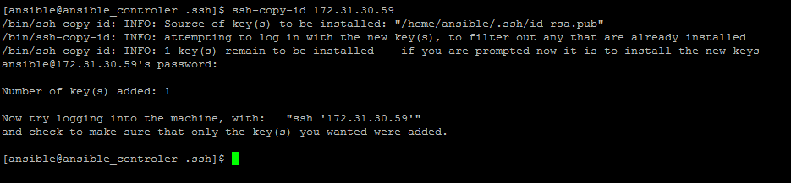

Now all is set.

Pls try to login to ansible_demo server(private ip) from ansible_controler server with SSH

